A

Documentation

on

***TRAFFIC BARRICADES***

**D.Varsha (19R01A0417)**

**G.Mahesh (19R01A0425)**

**M.kavya sree (19R01A0435)**

**M.Vishnu (19R01A0436)**

**MV.Pavan Rahul (19R01A0437)**

**V.Uday kiran (19R01A0455)**

**INDEX**

**Topics Page No**

**ACKNOWLEDGEMENT i**

**ABSTRACT ii**

**LIST OF FIGURES iii**

**CHAPTER-I INTRODUCTION 1-4**

* 1. Background **1**
  2. Motivation **3**
  3. Purpose of the Project **4**

**CHAPTER –II LITERATURE ON SURVEY 5**

* 1. Marketing Survey on existing Solution  **5**

**CHAPTER–III PROPOSED DESIGN**  **6-8**

**CHAPTER –IV METHODOLOGY 9-12**

**CHAPTER –V CONCLUSION** 1



**ABSTRACT**

**The traffic barricades** . Even after imposing heavy fines for jumping the signal many of them violate,Therefore if we install elevating traffic barricades near traffic signals when the signals turns red the barricades start to elevate from the ground surface which blocks the vehicles from jumping the signal.

**LIST OF FIGURES**

**Figure Description Page No**

**Figure 1.1 Elevating traffic barricates *1***

**Figure 1.2 implemented traffic barricades 2**

**Figure 3.1 Design Of Barricade Implimentation 6**

**Figure 3.2 Barricades at their initilize state 7**

**Figure 3.3 barricades after elevating 7**

**Figure 3.3 Barricade specifications 8**

**Figure 3.4 Few applications of Barricades 8**



**CHAPTER-1**

**INTRODUCTION**

**1.1 PROBLEM DEFINITION**

With the growth of the urbanization, industrialization and population, there has been a tremendous growth in the traffic. There is occurrence of bundle of problems too, these problems include signal jump, traffic jams, accidents and traffic rule violation. In 1868, the traffic lights only installed in London and today these have installed in every cities around the world. Today red light violation is one of the most common and serious problem which results in the collision of millions of vehicles at the traffic light signals every year. A red light violation occurs when a vehicle try to cross the intersection at the red traffic light.

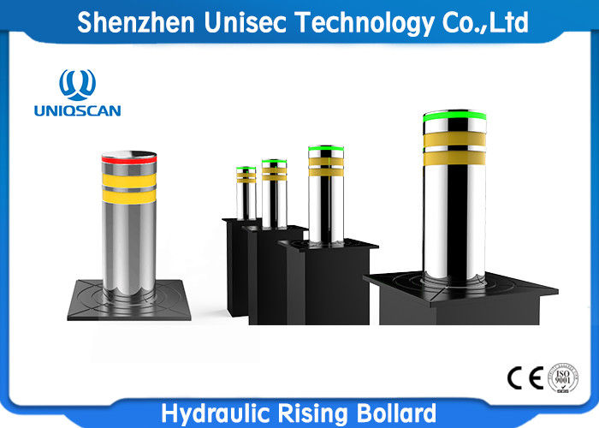



*Figure 1.1 Elevating traffic barricades*

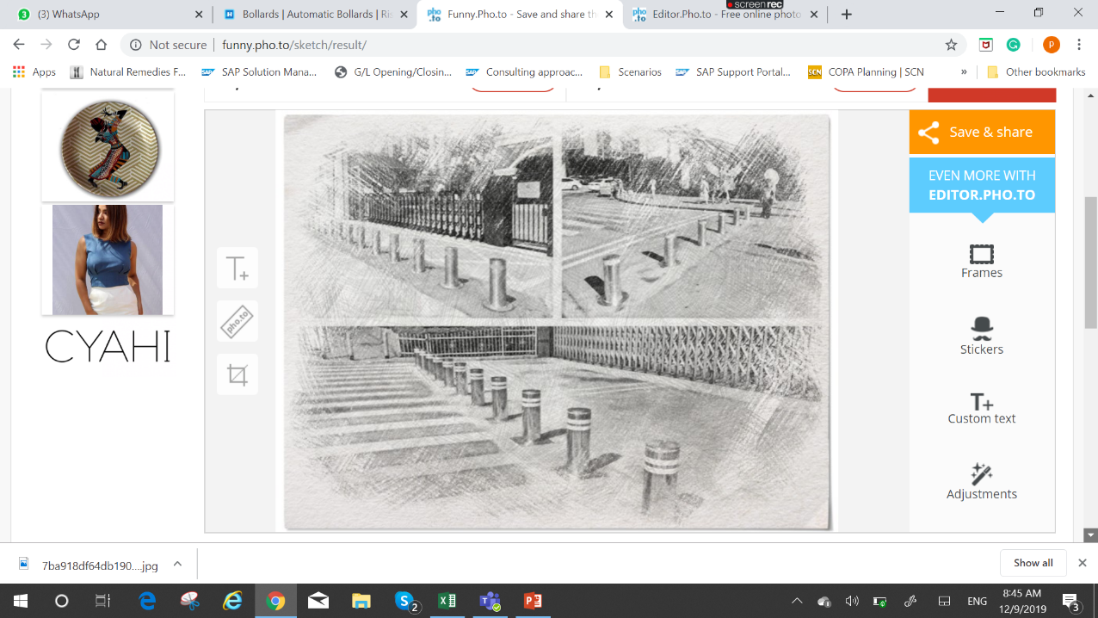

Figure 1.2 implemented traffic barricades

**1.2 MOTIVATION**

After Intensive Surveys We Have Understood That Jumping Traffic Signals Not Only Effect The Life Who Jumps The Signal But Also The One Who Travels In The Opposite Direction. The Red Light At A Traffic Signal Is The Most Critical Component Of Any Road Network. It Is The Simplest Instruction And Probably Among The First Few Things Taught To Anyone About Road Rules.

Yet, It Has Become The Most Compromised Rule. Even With Several Intersections Providing Countdowns, Motorists Often Proceed Before The Signal Turns Green Or Well After It Has Turned Red. We Ourself Got Motivated To Do This Project .We Want To Do This Project To Save Lives Not For Fame.

**1.3PURPOSE OF THE PROJECT**

After Considering The Problem We Have Discussed With Our Team And Came Out With An Innovative Solution Traffic Barricades . Even After Imposing Heavy Fines For Jumping The Signal Many Of Them Violate,Therefore If We Install Elevating Traffic Barricades Near Traffic Signals When The Signals Turns Red The Barricades Start To Elevate From The Ground Surface Which Blocks The Vehicles From Jumping The Signal.implementing the barricade is is the best solution for stop people from jumping the traffic signal which saves many lives.

**CHAPTER –II**

**LITERATURE ON SURVEY**

**Survey Report:**

Summary:

We spoke to the traffic police Mr Rajesh kumar . We asked different problems on jumping the traffic signals . He said jumping the signals causes serious impact on person who drives . The red light at a traffic signal is the most critical component of any road network. It is the simplest instruction and probably among the first few things taught to anyone about road rules.

The well-planned signals are ignored most of the time. Motorists rarely heed the red light, and often amble across the intersection at will. The peculiarity of this road is one of the reasons for this. Although a thoroughfare, Even in less busy roads cutting across it at every intersection. This means traffic flow along the main road has been given higher priority and the signals are timed appropriately. However, this sometimes results in underutilised green time. People heading straight down the main road sometimes end up having to wait for little or no traffic along the crossroads. Inevitably, in their frustration and haste, they jump the signal.

This is, in fact, more dangerous than jumping a red signal at a busy intersection (not that either can be condoned). The lack of traffic along the crossroads is the biggest problem for such arterial roads. The few vehicles traversing the quieter roads often accelerate to make sure they cross the intersection within the little time allocated for them. One can imagine how violating a red signal and getting in the way of those vehicles can lead to accidents, which occur with alarming frequency.

However, there is only so much any governing body can do. While one solution could be to improve signal timings and deploy traffic police to manage the traffic ad hoc, the better and obvious solution is to simply follow road rules. The inability to wait for our turn has become an omnipresent problem; from the security check at airports to a simple queue at the supermarket, we try to jump ahead of others.

But when it comes to vehicular traffic, the consequences can be severe. Let us not wait for a devastating accident or a hefty fine to shake us out of our indifference.

**CHAPTER –III**

**PROPOSED DESIGN**

Retractable bollards can be lowered entirely below the road surface to allow traffic to pass, or raised to block traffic or to enforce traffic rules that are time related.

Automatic Rising Bollards are equipped with compact hydraulic unit built with pump piston drive mechanism that makes it more suitable for smooth operations .

Performance: Automatic Rising Barricades characterized by high efficiency and complete performance. They are impeccable in their movement .

Intelligent Control Unit with versatile configuration makes it more flexible for different applications and integration. Intelligent unit provides unique feature and master slave kit allow smooth operation for entire set of barricades.

Safe: In-built hydraulic accumulator that allows, in case of emergency and with a specific command, to lift the bollard immediately and in-built pressure switch provide more safety by lowering down the bollard detection of any object during movement.

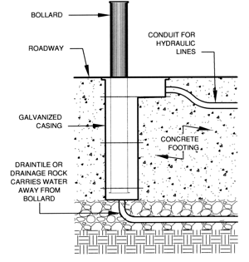

Figure 3.1 Design Of Barricade Implimentation



Figure 3.2 Barricades at their initilize state

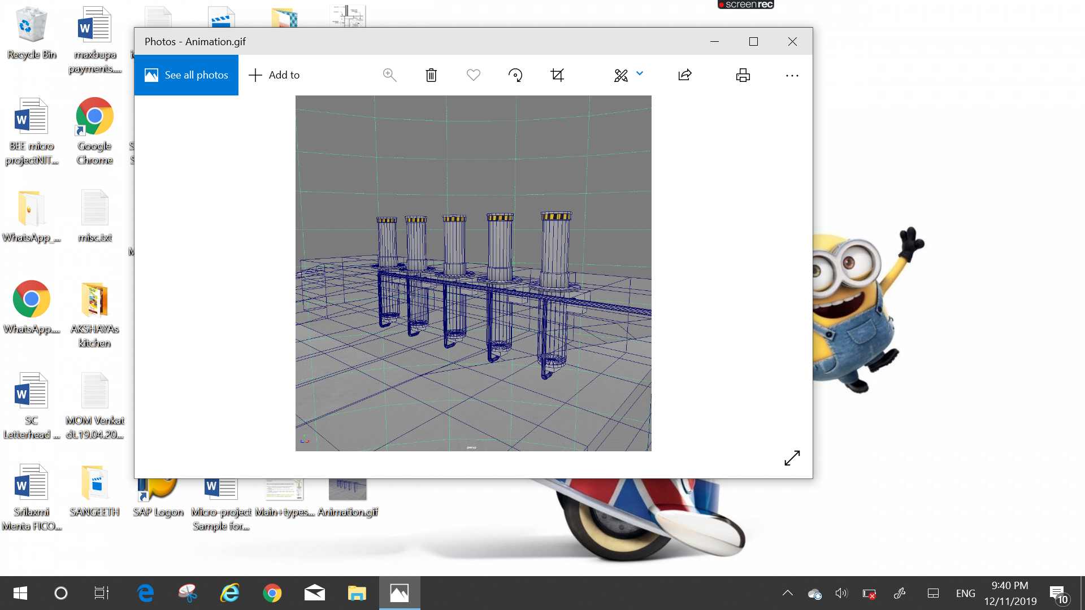



Figure 3.3 barricades after elevating

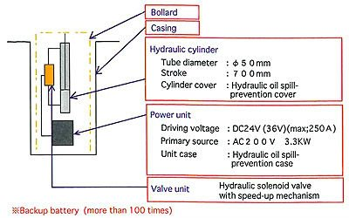

Figure 3.3 Barricade specifications

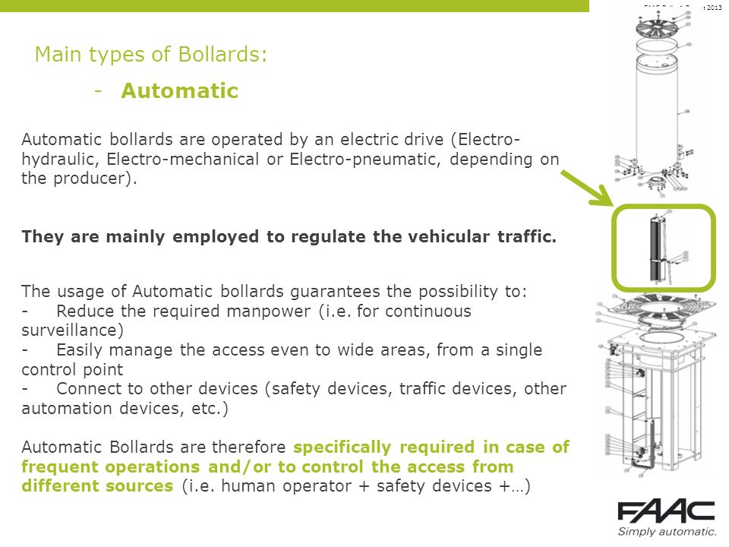



Figure 3.4 Few applications of Barricades

**CHAPTER –IV**

**METHODOLOGY**

Manufacturing of bollard system is done by using different performance categories, testing

methods, design calculations and guidelines .

Design Calculation:

Electro-Hydraulic Bollard consists of 3 cylinders of same sizes viz. Bore Diameter (D): 32mm, Piston Rod diameter (d): 25 mm, Stroke Lengthfrom BDC to TDC (S): 760 mm. Stroke Timing (ST)from BDC to TDC & vice-versa: 5 seconds. TotalForce/Weight on 3 cylinders (F): 2.5 tons.

Cylinder calculations are as follows:

Area of Bore Side of each Cylinder:?? = ????

2

/4.

AB =

0.785*3.2*3.2 cm2

AB = 8.04

cm2

ABT = 3* AB

ABT = 3*8.04 cm2

ABT = 24.12 cm2

Area of Annulus Side of each Cylinder: =

2

)/4.

AA =

0.785*(3.2*3.2-2.5*2.5) cm2

AA= 3.13 cm2

AAT = 3* AA

AAT = 3*3.13 cm2

AAT = 9.39 cm2

Volume required for each Cylinder: V =Area * Stroke Length.

Volume required on Bore Side of each cylinder:

VB=AB *S.

8.04 * 76 cm3

611.04 cm3 (Now 1 cm3 = .001 ltrs)

0.61 ltrs

For 3 nos. of Cylinders: VBT : VB *3 liters

VBT : 0.61*3 liters

VBT : 1.83 liters

Volume required on Bore Side of each cylinder:

AA*S.

3.13 * 76 cm3

237.88 cm3 (Now 1 cm3 = .001 liters)

0.238 liters

For 3 nos. of Cylinders: VAT : VA*3 liters

VAT : 0.238*3 liters

VAT : 0.71 liters

The three Cylinders have to operate within 5 seconds to lift the Bollard & to perform required safety operations. For this we need to provide the fluid to the Bore side of the Cylinder at a particular flow rate that could meet the function.

Similarly fluid needs to be admitted to Annulus side of the cylinder to retract the cylinder down. For this we will be requiring a Hydraulic oil Pump with a specific flow rate that could lift the cylinder up-to its full stroke length within the specified timing. Flow rate required to Lift/Retract the cylinders to full stroke length: (Volume/Stroke timing) liters per minute.

Flow Rate required to Lift the cylinders: QBT : VBT /T

(1.83 *60) /5 liters per minute

22 liters per minute.

Flow Rate required to retract the cylinders:

QAT: VAT / ST

(0.71 *60) /5 liters per minute 9 liters per

minute

Since the maximum Flow rate required is during Lifting hence the pump flow is selected according to the Lifting operation requirements. Also since it is a mechanical system there will be losses like slippage, leakages etc. which needed to be compensated & therefore a margin over the required flow rate is required.

We have considered 20% margin over the required

flow rate i.e.: Required flow rate * 1.20

22*1.20 liters per minute

26.4 liters per minute

Approx. 27 liters per minute.

he Pressure required to Lift the cylinders against the load is calculated using Pascal’s Law which states that:

Pressure = (Force or Weight/Area) Kg/cm2 or bar

Hence, Pressure Require for Lifting the Cylinders:

PBT = Force/ ABT

PBT = 2500/24.12 Kg/Cm2

PBT = 103.6 Kg/Cm2

Due to mechanical System there will be some losses such as heat, pressure drop across valves & in Pipes/Tubes; we have taken 10% margin over the

required pressure for lifting.

Therefore the Design pressure is taken as: PD - PBT *

1.1

PD = 103.6*1.1 Kg/Cm2

PD = 115 Kg/Cm2

The Hydraulic Oil Pump can be of different types such as External Gear Pump, Vane Pump, variable displacement axial piston Pump, and Internal gear Pump etc. Any of these pumps can be used depending on the application of the system. Now for driving the Hydraulic oil pump we need an AC Electric Motor of a particular rating. The Motor rating depends upon three factors viz. Pressure, Flow & efficiency of the Pump.

Motor kW can be calculated by below given formula:

1. Motor Rating (kW):- (Pressure X Flow

rate)/(600 X Overall efficiency of Oil Pump)

Efficiency of Oil Pump varies from type to type:

1. Variable Displacement Axial piston pump

: 90%

2. External Gear Pump : 65%

3. Internal Gear Pump : 75%

**CHAPTER –V**

**CONCLUSION**

Traffic Barricades Are Designed To Offer An Impactresistant Barrier To Vehicle Access Near Traffic Signals , Whilst Allowing Access To Pedestrians ,At Preasent Due To The Poor Management Of Traffic Management Number Of People Are Voilating The Traffic Rules Jumping The Signals Even After Imposing Heafty Fines They Tend To Do This .Therby We Want To Conclude Implementing The Traffic Barricdes Will Stop Everyone Jumping The Signas Saving Numbre Of Lives.